Q-1 What is jquery?

Ans. jquery is a JavaScript Library

It simplifies various tasks such as HTML document traversal and manipulation, event handling, animation, and Ajax interactions for web development. jQuery simplifies the process of writing JavaScript code that works across different browsers by providing a unified interface and abstraction over various browser inconsistencies. It was developed to mak.

Q-2 How to Apply CSS Using JQuery, How to Add Class and Remove Class in Jquery , JQuery Animation?

Ans. A. Applying css using jquery:

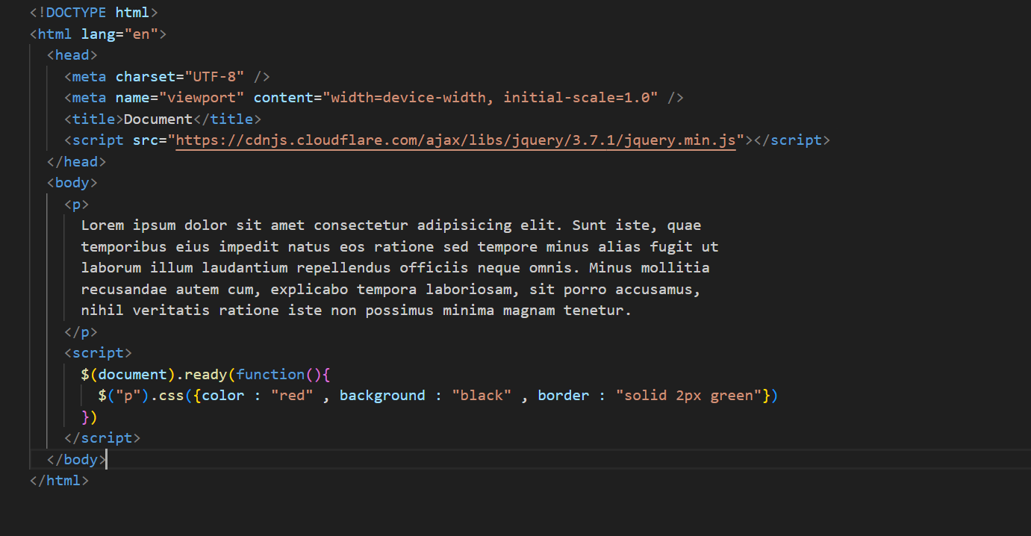

B. Adding and Removing classes in jquery:

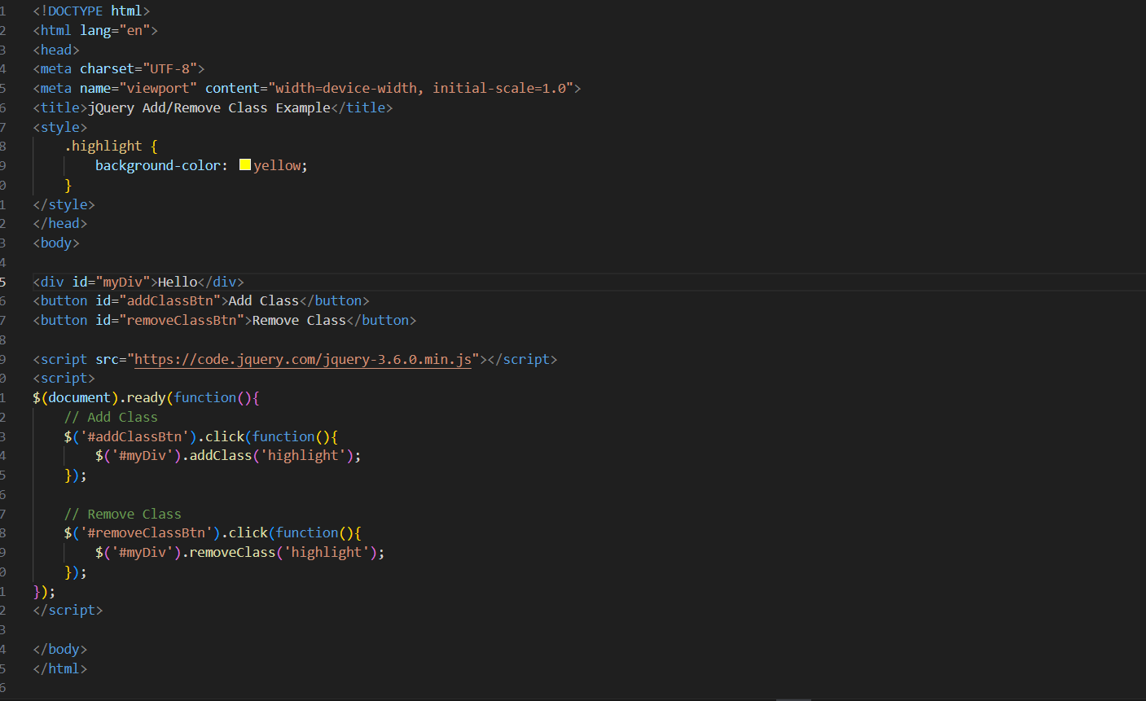

C. jquery animate:

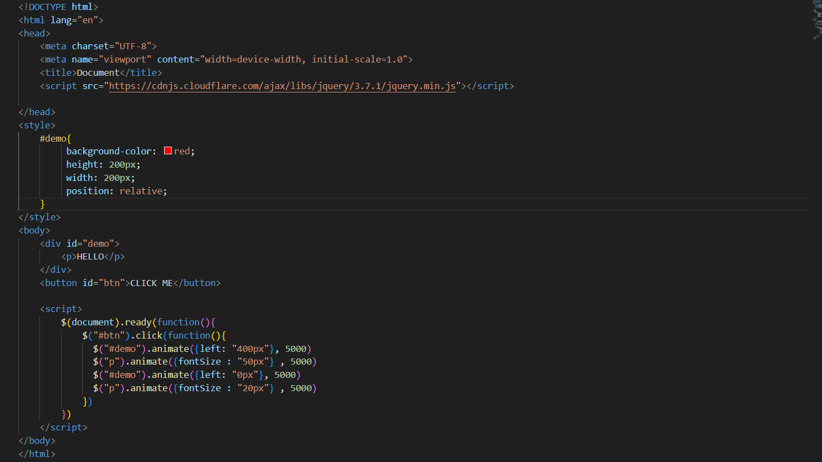

Q-3 How to create slider with animation?

Ans.

